SacraDigit: A SECURE CLOUD-BASED FRAMEWORK FOR SACRAMENTAL RECORD DIGITIZATION AND AUTOMATED PARISH RESOURCE SCHEDULING

A Thesis
Presented to the Faculty of the
Department of Computer Studies
College of Science
Technological University of the Philippines
Ayala Boulevard, Manila

In Partial Fulfillment of the
Requirements for the Degree
Bachelor of Science in Information Technology

RAMILO, KIRBY D.
CAMPOMANES, JUAN MIGUEL D.
SORIO, IA MARY R.
LAURENTE, ALTHEA MARIE S.

April 2026

Chapter 1

PROBLEM AND ITS SETTING

Background of the Study
The Catholic Church in the Philippines, with a history spanning more than five centuries and comprising over 80 million baptized faithful, is canonically required under Canon 535 of the Code of Canon Law to maintain accurate registers of baptisms, confirmations, marriages, and deaths. Despite this obligation, the majority of parishes across the country continue to rely on handwritten ledgers and loose-leaf physical files as the primary medium for capturing, storing, and retrieving sacramental and administrative data (Respicio, 2025). This manual approach introduces persistent operational difficulties, including time-intensive record searches, susceptibility to transcription errors, and the absence of systematic audit trails. A case study of the San Nicolas de Tolentino Parish in Bais City, Philippines, specifically documented that manual record-keeping in large handwritten books made searching time-consuming and raised risks of data loss, affirming that these conditions are not isolated but systemic across the Philippine parish context (Scribd, 2023).
The vulnerability of physical records is compounded by the tropical climatic conditions prevailing throughout the Philippines. Research on archival preservation has established that paper records in tropical environments may deteriorate to the point of irreversibility within 100 to 200 years, compared to approximately 1,000 years in temperate climates, owing to the accelerated chemical decomposition of cellulose at high temperatures and the biological attack facilitated by consistently elevated relative humidity (Teygeler, 2001). The Northeast Document Conservation Center (NEDCC, 2024) identifies high humidity as a direct catalyst for mold growth and pest activity in archival collections, conditions that prevail widely in Philippine parishes lacking climate-controlled storage. This gradual deterioration is further compounded by the catastrophic risks posed by typhoons, floods, and seismic events endemic to the archipelago. The FamilySearch organization, which collaborated with the Catholic Bishops' Conference of the Philippines to digitize over 400 years of parish records, confirmed that natural disasters had destroyed original registers in various localities, leaving digital reproductions as the sole surviving copies in certain instances (Church of Jesus Christ of Latter-day Saints, 2019).
The adoption of cloud-based technology offers a viable and documented pathway toward resolving these administrative and preservation deficiencies. Cloud platforms provide scalable, on-demand access to computing resources and secure document storage without requiring the capital investment associated with on-premises infrastructure. According to a market analysis by Straits Research (2023), the global church management software market was valued at approximately USD 245 million in 2022 and is projected to reach USD 393 million by 2031, reflecting measurable institutional demand for digital administrative tools among religious organizations. Central to any system managing ecclesiastical records is the implementation of Role-Based Access Control, a security model in which permissions are assigned to roles rather than individual users, ensuring that access to sensitive data conforms to an institution’s established hierarchy. Studies by Umar et al. (2023) and Akuthota (2025) have established that RBAC is particularly well-suited to organizations with clearly defined hierarchical structures and that hybrid metadata-driven RBAC architectures can reduce unauthorized data exposure by as much as 80 percent while maintaining regulatory compliance.
Notwithstanding the availability of these technologies, a critical gap persists between global developments in church management software and the specific administrative, regulatory, and infrastructural realities of Philippine parishes. Most existing platforms have been developed for North American and European congregations and do not account for the requirements imposed by Republic Act No. 10173, the Data Privacy Act of 2012, under which sacramental records are classified as sensitive personal data subject to the principles of transparency, legitimate purpose, and proportionality (Republic Act No. 10173, 2012). The National Privacy Commission has explicitly affirmed that these requirements apply to institutions that store and provide access to records containing personal information (NPC, 2018). Beyond compliance, the absence of a locally adapted unified digital platform means that parish financial records, sacramental registers, and scheduling tasks continue to be managed through incompatible and fragmented methods, introducing redundancy and preventing parishes from generating coherent administrative reports. Addressing these gaps is significant not only for the preservation of irreplaceable canonical records but also for the efficiency of parish operations, the protection of parishioners’ privacy rights, and the institutional capacity of the Church to fulfill its administrative obligations under both Canon and civil law.
The present study is grounded in the hypothesis that the implementation of a secure, role-based, cloud-hosted document management system tailored to the administrative structure and regulatory environment of Philippine Catholic parishes will demonstrably improve the efficiency, security, and retrievability of sacramental and administrative records relative to prevailing manual practices. It is further hypothesized that such a system can be designed to satisfy the data protection requirements of Republic Act No. 10173 while remaining operationally practical for parishes with limited technical staff, thereby addressing the gap that currently exists between the recognized need for digital transformation and its actual realization at the parish level.

Objectives of the Study
This study aims to design, develop, and evaluate SacraDigit, a secure cloud-based framework for sacramental record digitization and automated parish resource scheduling. Specifically, the study seeks to accomplish the following:
1. To design and develop a cloud-based web application featuring Role-Based Access Control that assigns distinct permission levels to parish administrators, authorized clergy, parish secretaries, finance officers, and read-only users, ensuring that access to sensitive documents and records is governed by role-appropriate authorization policies.
2. To implement a secure digital document repository within the system capable of storing and retrieving sacramental records including baptismal registers, confirmation records, marriage certificates and contracts, death records, and birth certificates, as well as parish financial records, using structured metadata to facilitate efficient search and retrieval.
3. To develop an automated mass and resource scheduling module that allows parish staff to manage liturgical schedules, event bookings, and facility reservations through a centralized interface, reducing scheduling conflicts and administrative overhead.
4. To evaluate the functional performance of the developed system in terms of usability, data integrity, security, and access control effectiveness through structured user acceptance testing conducted with representative parish staff profiles using privacy-compliant dummy documentation in lieu of actual personal records.
5. To assess the degree to which the system architecture satisfies the data protection principles established under Republic Act No. 10173 (Data Privacy Act of 2012) and the corresponding Implementing Rules and Regulations issued by the National Privacy Commission.
6. To identify remaining technical and operational gaps in the system following evaluation and to recommend improvements for future development and potential deployment in actual parish settings.f

Scope and Delimitation
This study is limited in scope to the design, development, and testing of a cloud-based web application intended to serve as a document management and scheduling platform for Catholic parishes in the Philippines. The types of documents that the system is designed to store and manage are specifically restricted to records of direct administrative relevance to parish operations, namely: baptismal certificates and sacramental registers, birth certificates submitted in connection with sacramental preparation, confirmation records, marriage certificates and marriage contracts, death certificates, records of Mass intentions, liturgical scheduling data, and parish financial records including statements of income and expenditure, official receipts, and budgetary documents. The decision to limit the document scope to these categories reflects both the immediate needs of parish administration and the necessity of maintaining a manageable and testable system scope within the constraints of this research.
The system will be developed and evaluated using dummy files and simulated documents in place of actual sacramental records. This constraint is imposed by the provisions of Republic Act No. 10173, otherwise known as the Data Privacy Act of 2012, which governs the handling of personal information in both government and private information systems in the Philippines. Sacramental records inherently contain sensitive personal data including full names, birth dates, place of birth, parentage, spousal information, and in the case of death records, cause of death. The use of actual records from real parishioners in a research context would expose both the researchers and the participating institution to potential violations of the Act's requirements concerning purpose limitation, data minimization, and authorized processing. By employing representative dummy files designed to replicate the structure, format, and informational complexity of genuine parish documents, this study is able to demonstrate the full functional capability of the system, including upload, classification, storage, retrieval, access control enforcement, and audit logging, without compromising the privacy rights of any individual whose data might otherwise appear in real records. This approach also allows the system to be tested in a controlled and reproducible environment, ensuring that findings can be validated independently.
The system is further delimited to the functional requirements of a single-parish deployment and does not extend to multi-site diocesan administration or inter-parish data sharing. The scheduling module is confined to Mass scheduling, parish event management, and facility bookings and does not encompass broader diocesan calendar management or seminary administration. The study does not include the development of a mobile application interface, though the web-based interface is designed to be responsive to various screen sizes. The system is not intended to serve as a replacement for the Philippine Statistics Authority's civil registration processes or for canonical archives maintained at the diocesan level, but rather as a parish-level operational tool that can improve the administrative management of documents that parishes are already required to maintain under both Canon Law and civil regulations.

Significance of the Study
The findings and outputs of this study hold significance for a range of stakeholders across the ecclesiastical, governmental, academic, and civil society domains. The following parties stand to benefit from the successful development and evaluation of SacraDigit.
Parish Priests and Clergy. As the primary administrators of parish operations, parish priests bear canonical and institutional responsibility for the accuracy and security of sacramental registers. SacraDigit provides them with a system through which they can exercise administrative oversight without being burdened by the manual labor of record retrieval. The role-based permission model ensures that the parish priest retains ultimate authority over document management while delegating routine access to appropriate staff.
Parish Administrative Staff. Secretaries, bookkeepers, and sacristans who carry out the daily clerical work of parish administration stand to benefit directly from the efficiency gains offered by the system. The ability to retrieve, classify, and issue document copies through a digital platform significantly reduces the time and effort invested in manual record searches, allowing staff to redirect their attention toward more substantive service tasks.
Parishioners and the General Catholic Public. Filipino Catholics who require certified copies of their sacramental certificates for legal, educational, and civil purposes will benefit from reduced processing times and improved reliability of issuance. The system's structured document retrieval mechanisms reduce the likelihood that requests are delayed by misfiled or deteriorated records.
Diocesan Offices and the Catholic Bishops' Conference of the Philippines. Diocesan administrators and the CBCP, as bodies responsible for overseeing the canonical and administrative integrity of constituent parishes, benefit from any development that improves the reliability and security of parish record-keeping. A standardized digital framework applicable across parishes also creates the foundation for potential future integration of diocesan-level oversight and reporting capabilities.
Philippine Statistics Authority and Local Civil Registrars. Civil authorities that rely on sacramental records as supporting documentation for civil registration processes benefit from a more organized and verifiable source of ecclesial records. Improved accuracy and accessibility at the parish level reduces errors and delays that affect the civil registration system downstream.
Researchers and the Academic Community. This study contributes to the limited body of literature addressing the application of cloud-based document management and RBAC systems within the Philippine religious institutional context. It provides a documented design framework, evaluation methodology, and findings that future researchers may build upon in developing or refining similar systems for other institutional settings.
Information Technology Professionals and System Developers. Practitioners engaged in the design of document management solutions for non-profit and religious organizations will find in this study a documented framework that integrates RBAC, cloud storage, and Data Privacy Act compliance in a single system architecture. The methodology and design decisions recorded here may serve as a reference for analogous deployment contexts.
Policy Makers and the National Privacy Commission. This study demonstrates a practical application of Republic Act No. 10173 in an institutional context that has not previously received systematic attention within the privacy compliance literature. The findings may inform NPC guidance materials and policy instruments directed at religious organizations as personal information controllers under the Act.

References:
Akuthota, A. K. (2025). Role-based access control (RBAC) in modern cloud security governance: An in-depth analysis. International Journal of Scientific Research in Computer Science, Engineering and Information Technology, 11(2). https://www.ijsrcseit.com/index.php/home/article/view/CSEIT25112793
BTO Ohio. (2023). How to implement a document management system in your religious organization. BTO Ohio Blog. https://blog.btohio.com/how-to-implement-a-document-management-system-in-your-religious-organization-1
Church of Jesus Christ of Latter-day Saints. (2019). FamilySearch donates 400 years of digitized Catholic records in the Philippines. Church News and Events. https://www.churchofjesuschrist.org/church/news/familysearch-donates-400-years-of-digitized-catholic-records-in-the-philippines?lang=eng
National Privacy Commission. (2018). Advisory opinion no. 2018-037: Data privacy in archives and libraries [Advisory Opinion]. Republic of the Philippines. https://privacy.gov.ph/wp-content/uploads/2022/01/AONo.2018-037.pdf
Northeast Document Conservation Center. (2024). 2.1 Temperature, relative humidity, light, and air quality: Basic guidelines for preservation. NEDCC Preservation Leaflets. https://www.nedcc.org/free-resources/preservation-leaflets/2.-the-environment/2.1-temperature,-relative-humidity,-light,-and-air-quality-basic-guidelines-for-preservation
Republic Act No. 10173, Data Privacy Act of 2012, Republic of the Philippines (2012). https://privacy.gov.ph/data-privacy-act/
Respicio, J. L. (2025). How to locate your baptismal record in a church. Respicio & Co. Legal Commentaries. https://www.respicio.ph/commentaries/how-to-locate-your-baptismal-record-in-a-church
Scribd. (2023). Church management system 1 [Document]. Scribd. https://www.scribd.com/document/716587473/Church-Management-System1
Singh, J., Rani, S., & Kumar, V. (2024). Role-based access control (RBAC) enabled secure and efficient data processing framework for IoT networks. International Journal of Communication Networks and Information Security (IJCNIS), 16. https://www.researchgate.net/publication/383295659
Smithsonian Institution Archives. (n.d.). Environment. Smithsonian Institution Archives. https://siarchives.si.edu/what-we-do/preservation/environment
Straits Research. (2023). Global church management software market size is estimated to reach USD 393 million by 2031, growing at a CAGR of 5.4%. GlobeNewswire. https://www.globenewswire.com/news-release/2023/11/29/2787679/0/en/Global-Church-Management-Software-Market
Tabernacle. (2024). Digitizing church records: How to effectively migrate and preserve history? Tabernacle Blog. https://tabernacle.app/blog/digitizing-church-records
Teygeler, R. (2001). Preservation of archives in tropical climates: An annotated bibliography. International Council on Archives / UNESCO. https://cool.culturalheritage.org/byauth/teygeler/tropical.pdf
Umar, S., et al. (2023). Role-based access control (RBAC) vs. attribute-based access control (ABAC) for cloud security. Educational Administration: Theory and Practice, 29(3), 1398–1406. https://kuey.net/index.php/kuey/article/download/9454/7199/17946

Chapter 2

CONCEPTUAL FRAMEWORK

Review of Related Literature

Introduction
Catholic parishes in the Philippines manage a wide range of administrative functions that are both canonically mandated and legally regulated. Chief among these responsibilities is the maintenance of sacramental records—registers of baptisms, marriages, and deaths that serve as essential legal and historical documents for parishioners. Despite the critical nature of these records, the majority of parishes continue to rely on handwritten ledgers, physical filing systems, and manual scheduling practices that are vulnerable to deterioration, loss, and unauthorized access. The development of the SacraDigit system responds to this gap by providing a cloud-based, role-protected framework for the digitization, archival, and administrative management of parish records and resources.
This section reviews prior studies and industry frameworks that informed the development of SacraDigit. It focuses on five core themes: cloud computing and document management systems, role-based access control and security frameworks, archival preservation and disaster recovery, data privacy and regulatory compliance in the Philippines, and ecclesiastical administration and sacramental record-keeping.

Cloud Computing and Document Management Systems
Cloud computing represents a paradigm shift in the provisioning and consumption of computing resources, characterized by on-demand self-service, broad network access, resource pooling, rapid elasticity, and measured service. These essential characteristics, as defined by the National Institute of Standards and Technology, enable organizations to access scalable infrastructure without incurring the capital expenditures associated with traditional on-premises deployments (Mell & Grance, 2011). The applicability of cloud computing to document management has been extensively documented across various organizational contexts, including healthcare, education, and government administration. Ramachandra et al. (2017) demonstrated that cloud-based document management systems offer significant advantages in terms of accessibility, disaster recovery, and cost efficiency compared to local storage solutions, particularly for organizations with geographically distributed operations and limited IT personnel.
The architectural principles underlying cloud-based document repositories emphasize redundancy, geographical distribution, and automated backup procedures. Singh and Chatterjee (2017) conducted a comparative analysis of cloud storage architectures for sensitive documents and found that distributed file systems with geographically redundant nodes provided the highest levels of data durability. Their study specifically addressed the challenges faced by non-profit organizations with limited technical expertise, concluding that managed cloud services from established providers offered superior reliability and security compared to self-hosted alternatives when internal IT capacity was constrained. This finding is directly relevant to the parish context, where administrative staff typically lack specialized training in systems administration.
The market for church-specific management software has expanded substantially in recent years. According to market research conducted by Straits Research (2023), the global church management software industry was valued at approximately 245 million United States dollars in 2022 and is projected to reach 393 million dollars by 2031. However, the research noted that adoption in Asia, including the Philippines, remained below 10 percent—a disparity attributed to cost barriers, limited internet infrastructure in rural areas, and the absence of localized platforms that accommodate region-specific regulatory requirements.

Role-Based Access Control and Security Frameworks
Role-based access control constitutes a foundational security model in which permissions to access resources are assigned to roles rather than to individual users, with users subsequently assigned to roles based on their organizational functions. This model was formalized by Ferraiolo and Kuhn (1992) in their seminal work for the National Institute of Standards and Technology, which established the core principles of role hierarchies, separation of duties, and least privilege. The RBAC model has since become the de facto standard for access control in hierarchical organizations because it aligns permission structures with established organizational hierarchies and simplifies administration.
Empirical studies have demonstrated the effectiveness of RBAC in reducing unauthorized access incidents while maintaining operational efficiency. Research across organizations in healthcare, education, and financial services has found that organizations employing RBAC experience significantly fewer unauthorized data access incidents compared to those using discretionary access control models. This improvement is attributed to the reduced complexity of permission management and the enforceability of separation-of-duties constraints inherent to RBAC architectures. These efficiency gains are particularly relevant in resource-constrained environments such as parish offices, where administrative staff must manage multiple responsibilities concurrently.
The implementation of RBAC in cloud-based systems introduces additional technical considerations related to multi-tenancy, identity federation, and session management. Hu et al. (2014) examined cloud-specific RBAC implementations and identified three architectural patterns: application-layer RBAC, infrastructure-layer RBAC, and federated RBAC that integrates with external identity providers. For systems managing sensitive personal data, the study recommended application-layer RBAC supplemented by encryption at rest and in transit, regardless of the underlying cloud platform's native security features.

Archival Preservation and Disaster Recovery
The preservation of paper-based archival materials in tropical climates presents significant challenges arising from elevated temperature and humidity, biological attack, and chemical degradation. Research conducted by Teygeler (2001) on the preservation of archives in tropical climates established that paper documents stored under sustained high relative humidity and temperature undergo accelerated cellulose hydrolysis. The study concluded that documents stored without climate control in tropical environments could deteriorate to the point of irreversibility within 100 to 200 years, compared to approximately 1,000 years for equivalent documents stored in temperate climates.
The Northeast Document Conservation Center (2024) identified high humidity as the single most consequential factor in the deterioration of paper collections, noting that relative humidity above 65 percent creates conditions conducive to mold growth, insect activity, and accelerated chemical decomposition. The bulletin specifically identified tropical and subtropical climates as high-risk environments requiring either climate-controlled storage or alternative preservation strategies such as digitization and offsite backup.
The vulnerability of physical archives to catastrophic loss from natural disasters has been extensively documented in the Philippine context. The Philippines is among the most disaster-prone countries globally, experiencing an average of 20 tropical cyclones annually, frequent seismic activity, and flooding associated with the southwest monsoon (Cinco et al., 2014). Historical documentation of disaster impacts on ecclesiastical archives includes the loss of colonial-era parish registers during Typhoon Haiyan in 2013, which destroyed or severely damaged records in parishes across Leyte and Samar provinces. The FamilySearch organization, in collaboration with the Catholic Bishops' Conference of the Philippines, has conducted an extensive digitization initiative specifically motivated by the preservation of records at risk of catastrophic loss (Church of Jesus Christ of Latter-day Saints, 2019).
Matthews et al. (2009) examined archival recovery following Hurricane Katrina and found that institutions with offsite digital backups were able to resume operations within days, while those relying solely on physical records required months to years to reconstitute essential documentation. This principle is directly applicable to the Philippine context, where typhoons and earthquakes can affect entire provinces simultaneously.

Data Privacy and Regulatory Compliance in the Philippines
The Data Privacy Act of 2012, formally designated as Republic Act No. 10173, establishes the legal framework governing the processing of personal information in the Philippines. The Act applies to both government and private entities that process personal data within Philippine territory. The Act defines sensitive personal information to include information relating to an individual's religious beliefs or affiliations, health status, and personal circumstances—all of which are commonly present in sacramental records maintained by Catholic parishes (Republic Act No. 10173, 2012, Section 3).
The Act establishes three foundational principles for lawful data processing: transparency, legitimate purpose, and proportionality. Transparency requires that data subjects be informed of the fact of data collection and the purposes for which data is processed. Legitimate purpose mandates that data may only be processed for purposes declared at the time of collection, and proportionality requires that data collected be adequate, relevant, and not excessive in relation to the declared purposes (Republic Act No. 10173, 2012, Section 11).
The Implementing Rules and Regulations issued by the National Privacy Commission in 2016 provide detailed operational guidance on compliance requirements. The IRR specifies that personal information controllers must implement organizational, physical, and technical security measures appropriate to the sensitivity of the data being processed (National Privacy Commission, 2016, Rule VII). For sensitive personal information, the IRR mandates encryption during transmission and storage, access controls that limit data access to authorized personnel, and audit mechanisms that log all instances of data access and modification.

Ecclesiastical Administration and Sacramental Record-Keeping
The canonical obligation of Catholic parishes to maintain sacramental registers is codified in the Code of Canon Law promulgated in 1983. Canon 535 stipulates that in each parish there is to be a book of baptisms, a book of marriages, and a book of deaths, along with other registers as prescribed by the Episcopal Conference or the diocesan bishop (Code of Canon Law, 1983, Canon 535). These requirements constitute legal obligations under the internal law of the Catholic Church, enforceable through canonical procedures.
The practical implementation of sacramental record-keeping in Philippine parishes has been characterized by reliance on handwritten ledgers and loose-leaf filing systems. Parish staff typically spend considerable time per document retrieval request searching through chronologically organized ledgers, with unsuccessful searches occurring due to misfiled or illegible entries. The large format and weight of bound ledgers make them difficult to handle and transport, and historical entries have faded to the point of illegibility in documents older than several decades. These conditions prevail across Philippine parishes, particularly in rural dioceses where resources for archival preservation are limited.
The digitization of ecclesiastical archives has been undertaken in various national contexts. The FamilySearch initiative, in the Philippines, has resulted in the digitization of over 400 years of sacramental records from more than 1,200 parishes, with digital images made accessible through online repositories (Church of Jesus Christ of Latter-day Saints, 2019). However, this initiative focused exclusively on creating digital images of existing registers and did not extend to the development of searchable databases or administrative management systems for ongoing parish operations.
Parish scheduling encompasses liturgical events, facility bookings, volunteer coordination, and sacramental preparation programs, all of which involve temporal constraints and resource dependencies. Common challenges arising from manual calendar management include double-booking of facilities, inadequate notice to volunteers, and scheduling of events during times when necessary clergy or staff are unavailable. Effective automated scheduling systems for this context require conflict detection, automated notification, integration with sacramental preparation workflows, and the ability to accommodate both recurring and one-time events.

Related Studies
Several research and development projects have addressed the use of digital record management, cloud-based systems, role-based access control, and church administration tools, offering relevant insights into system architecture, usability, security frameworks, and evaluation methodologies. These studies inform the present research design, particularly its emphasis on cloud deployment, role-based access control, data privacy compliance, and the integration of administrative functions specific to the ecclesiastical context. The studies reviewed below were selected from academic journals and conference proceedings published between 2024 and 2026 to ensure currency and alignment with the contemporary technological landscape.

Cloud-Based Document Management for Organizational Record Systems.
SkyQuestT (2025) published a comprehensive market and systems analysis of the global church management software sector, reporting that the market reached USD 272.17 million in 2024 and is projected to grow to USD 414.55 million by 2032, driven primarily by the increasing shift of religious organizations from paper-based to cloud-based digital workflows. The analysis documented that cloud-based deployment now accounts for approximately 60 to 65 percent of all church management system installations globally, and highlighted that adoption in Asia-Pacific and Southeast Asian markets remains significantly below global averages due to the absence of localized platforms compliant with regional data privacy regulations. These findings directly contextualize the research gap that SacraDigit addresses: the absence of a cloud-based parish management system designed specifically for the operational realities and regulatory requirements of Philippine Catholic parishes.

Role-Based Access Control in Modern Cloud Security Governance.
Akuthota (2025) examined the evolving role of role-based access control in cloud security governance, with specific focus on its implementation in enterprise cloud platforms. The study analyzed real-world RBAC deployments and demonstrated that AI-enhanced RBAC frameworks achieved a 92.7 percent reduction in role configuration errors compared to manually administered permission systems, while also significantly improving regulatory compliance audit outcomes. The study identified three primary architectural benefits of modern RBAC in cloud environments: automated enforcement of privilege ceilings at execution time, integration with identity federation systems, and real-time anomaly detection for unauthorized access attempts. These findings directly informed the access control architecture of SacraDigit, where distinct roles for parish priest, parish secretary, and public users are defined and enforced at the application layer through Firebase Authentication and Firestore Security Rules.

Singh et al. (2024) further validated the applicability of RBAC frameworks in network-based systems managing sensitive personal data, comparing RBAC against attribute-based and policy-based access control models. Their analysis, published in the International Journal of Communication Networks and Information Security, found that RBAC remains the most scalable and administratively efficient model for large user bases organized into stable hierarchical roles, a condition that directly applies to the parish administrative structure. The study also identified integration with encryption as a critical supplementary control for sensitive data environments. SacraDigit implements this recommendation by combining Firebase's RBAC enforcement with Firestore's encryption-at-rest and in-transit capabilities.

Digital Archival Preservation and Manuscript Digitization.
Abdoh (2025) conducted an empirical study of a large-scale manuscript digitization initiative at the King Abdulaziz Complex for Endowment Libraries, published in Restaurator: International Journal for the Preservation of Library and Archival Material. The study documented that digitization of fragile and deteriorating manuscript collections not only preserved content against physical loss but also substantially improved access for researchers who previously required physical presence for document retrieval. The study identified standardized metadata management, secure cloud storage with redundancy, and access-controlled digital interfaces as the three critical infrastructure components for sustainable digital archival systems. These components map directly to the functional requirements of SacraDigit's Digital Archives module, which provides structured metadata fields for sacramental records, Firebase cloud storage with geographical redundancy, and role-controlled access through the Admin portal.

Shchepanskyi et al. (2025), writing in the International Journal on Culture, History, and Religion, conducted a cross-national audit of digital heritage preservation projects and found that cloud-based archival platforms significantly outperformed locally hosted alternatives in terms of disaster recovery capability, long-term accessibility, and cost efficiency for institutions with limited technical personnel. Their findings are particularly relevant to the Philippine context, where typhoons and seismic events pose recurring threats to physical archives, and where parish administrative staff typically lack the technical capacity to maintain locally hosted server infrastructure. The study concluded that managed cloud platforms represent the most appropriate archival infrastructure for resource-constrained cultural and religious institutions.

Data Privacy Compliance in Sensitive Information Systems.
Technavio (2025) published a market intelligence report on the church management software sector that identified data security and privacy as the foremost barrier to technology adoption among religious organizations. According to the report, a 2024 survey by Pushpay found that 14 percent of church leaders expressed high concern about privacy and data security risks associated with digital systems, with the primary concerns centering on unauthorized access to sensitive member information and compliance with applicable data protection regulations. The report documented that cloud-based church management systems addressing these concerns through encryption, role-based access controls, and multi-factor authentication demonstrated significantly higher adoption rates among institutionally sophisticated religious organizations. These findings validate the design priority assigned to data privacy compliance in SacraDigit, where the system's RBAC architecture, Firebase encryption, and audit logging capabilities are explicitly structured to satisfy the requirements of Republic Act No. 10173.

Church Management Software and Digital Transformation of Religious Organizations.
SkyQuestT (2025) further documented that the primary drivers of church management software adoption in 2024 included the growing complexity of event coordination, the need for data-driven decision-making, and the increasing adoption of online donation platforms. The report noted that in June 2024, Planning Center Online—a leading church management platform—merged with a volunteer management and scheduling application to provide churches with an integrated scheduling, communication, and resource management solution. This merger reflects the industry trend toward consolidated, multi-functional platforms that address scheduling, records management, and financial tracking within a single system architecture. SacraDigit is designed around this same integration principle, providing unified management of scheduling, digital archives, finance, and communications within a single cloud-based platform tailored to the regulatory and operational context of Philippine Catholic parishes.

System Website Structure
The SacraDigit system is organized into two primary access layers: a public-facing User portal for parishioners and a secured Admin portal for parish office staff and clergy. This two-tiered architecture reflects the role-based access control principles discussed in the literature review, ensuring that sensitive record management functions remain restricted to authorized personnel while providing accessible self-service tools for parishioners.
Table 1 presents the complete website structure of SacraDigit, mapping each module and its corresponding pages across both the User and Admin interfaces.

Table 1: Website Structure of SacraDigit Parish Management System
Module / Page | Section | Description
USER (Parishioner / Public)
Home | Dashboard | Highlights of upcoming masses and latest announcements.
 | Mass Times | Regular schedules, Holy Hour, and special liturgical events.
About | Parish History | Information about the church and SacraDigit digitization efforts.
 | Clergy & Staff | Profiles of the parish priest and administrators.
Offers (Services) | Schedule Availability | Real-time view of available slots for sacraments and blessings.
 | Process Guides | Requirements for Baptism, Wedding, and Death certificates.
Donations | Digital Giving | Secure portal for tithes, offerings, or specific project donations.
 | Mass Intentions | Form to submit names and intentions for upcoming masses.
Support | Contact Us | Inquiry forms and location maps.
 | FAQ | Common questions about records and scheduling.
ADMIN (Parish Office / Clergy)
Home (Dashboard) | Today's Schedule | Quick view of the day's masses and blessings.
 | Pending Requests | Counter for new applications needing approval.
 | Cloud Status | Direct link to monitor Firebase storage and records.
Scheduling Management | Sacramental Masses | Managing Binyag (Baptism), Patay (Funeral), First Communion, and Weddings.
 | Blessings | Coordination for Car, Motor, and House blessing requests.
 | Facility Booking | Managing the Multipurpose Hall (1st and 3rd Floor) reservations.
Digital Archives (SacraDigit Core) | Record Requests | Processing requests for Death and Baptismal certificates.
 | Cloud Access | Secure interface to search, update, or retrieve records within Firebase.
Finance & Intentions | Mass Intentions | List of names and intentions for daily and special masses.
 | Donations | Tracking and recording of parish contributions.
Communications | Announcements | Creating and editing upcoming event posts.
 | Special Mass Updates | Overriding regular schedules for Holy Week, Feasts, etc.
Figure 1. Website Structure of SacraDigit Parish Management System

System Website Structure
The SacraDigit system is organized into two primary access layers: a public-facing User portal for parishioners and a secured Admin portal for parish office staff and clergy. This two-tiered architecture reflects the role-based access control principles discussed in the literature review, ensuring that sensitive record management functions remain restricted to authorized personnel while providing accessible self-service tools for parishioners.
Table 1 presents the complete website structure of SacraDigit, mapping each module and its corresponding pages across both the User and Admin interfaces.

Table 1: Website Structure of SacraDigit Parish Management System
Module / Page | Section | Description
USER (Parishioner / Public)
Home | Dashboard | Highlights of upcoming masses and latest announcements.
 | Mass Times | Regular schedules, Holy Hour, and special liturgical events.
About | Parish History | Information about the church and SacraDigit digitization efforts.
 | Clergy & Staff | Profiles of the parish priest and administrators.
Offers (Services) | Schedule Availability | Real-time view of available slots for sacraments and blessings.
 | Process Guides | Requirements for Baptism, Wedding, and Death certificates.
Donations | Digital Giving | Secure portal for tithes, offerings, or specific project donations.
 | Mass Intentions | Form to submit names and intentions for upcoming masses.
Support | Contact Us | Inquiry forms and location maps.
 | FAQ | Common questions about records and scheduling.
ADMIN (Parish Office / Clergy)
Home (Dashboard) | Today's Schedule | Quick view of the day's masses and blessings.
 | Pending Requests | Counter for new applications needing approval.
 | Cloud Status | Direct link to monitor Firebase storage and records.
Scheduling Management | Sacramental Masses | Managing Binyag (Baptism), Patay (Funeral), First Communion, and Weddings.
 | Blessings | Coordination for Car, Motor, and House blessing requests.
 | Facility Booking | Managing the Multipurpose Hall (1st and 3rd Floor) reservations.
Digital Archives (SacraDigit Core) | Record Requests | Processing requests for Death and Baptismal certificates.
 | Cloud Access | Secure interface to search, update, or retrieve records within Firebase.
Finance & Intentions | Mass Intentions | List of names and intentions for daily and special masses.
 | Donations | Tracking and recording of parish contributions.
Communications | Announcements | Creating and editing upcoming event posts.
 | Special Mass Updates | Overriding regular schedules for Holy Week, Feasts, etc.
Figure 1. Website Structure of SacraDigit Parish Management System

The User portal is designed to be publicly accessible and requires no authentication, allowing parishioners to view mass schedules, submit service requests, make donations, and access support resources. The Admin portal, by contrast, is secured behind role-based authentication, granting parish staff access to the SacraDigit digital archive core, scheduling management tools, financial tracking, and communications management. This structural separation aligns with the principle of least privilege established in RBAC literature and ensures compliance with data privacy provisions of Republic Act No. 10173.
The User portal is designed to be publicly accessible and requires no authentication, allowing parishioners to view mass schedules, submit service requests, make donations, and access support resources. The Admin portal, by contrast, is secured behind role-based authentication, granting parish staff access to the SacraDigit digital archive core, scheduling management tools, financial tracking, and communications management. This structural separation aligns with the principle of least privilege established in RBAC literature and ensures compliance with data privacy provisions of Republic Act No. 10173.

Conceptual Model of the Study
The conceptual framework of this study is presented using the Input–Process–Output (IPO) model, illustrated in Table 2. This structure outlines the elements involved in the development, deployment, and evaluation of SacraDigit—a cloud-based parish document management and scheduling system—highlighting how the system was shaped by both technical and user-centered considerations.

Table 2: Input–Process–Output (IPO) Model of the SacraDigit System

INPUT | PROCESS | OUTPUT
Review of Related Literature and Studies  Cloud computing and RBAC frameworks  Philippine data privacy laws (RA 10173)  Canonical obligations (Code of Canon Law)  Tropical archival preservation research  Resources:  Hardware (computer, internet, scanner)  Software: HTML, CSS, JavaScript, Node.js, Firebase/Firestore  Development: Visual Studio Code  Stakeholders:  Parish priest, Parish secretary, Parishioners (public)  User Requirements:  Sacramental record digitization  Scheduling of masses and blessings  Role-based access control  RBAC compliance with RA 10173 | 1. Planning & Analysis  Identify operational gaps in manual record-keeping and scheduling  Gather requirements from parish staff  2. Design  Use Case, Context, and Data Flow Diagrams  Define cloud architecture (Firebase/Firestore)  Entity Relationship Diagram (ERD)  Wireframes and navigation flows  3. Development  HTML/CSS/JavaScript for front-end  Node.js backend with Express routing  Firebase integration for RBAC and storage  CRUD operations across all modules  4. Testing & Improvement  Functional suitability testing  Usability evaluation (ISO/IEC 25010)  Data privacy compliance review | SacraDigit — Cloud-Based Parish Management System  User (Public) Portal:  Mass Times & Announcements  Service Request Forms  Donation & Mass Intentions  FAQ & Contact Support  Admin (Parish Office) Portal:  Digital Archives (Baptismal, Wedding, Death records)  Scheduling Management  Facility Booking  Finance & Intentions Tracking  Communications Management  Evaluation:  ISO/IEC 25010 quality assessment  RA 10173 compliance verification
Figure 2. Input–Process–Output (IPO) Model of the SacraDigit System

Input
The input block encompasses all foundational knowledge, literature, regulatory frameworks, tools, and specifications necessary for the project. The review of related literature provided theoretical grounding in cloud computing architectures, role-based access control, tropical archival preservation, Philippine data privacy law, and canonical obligations for sacramental record-keeping. These sources collectively defined the requirements that SacraDigit must satisfy.
• Review of Related Literature and Studies:
- Cloud computing and document management principles applicable to non-profit institutions (Mell & Grance, 2011; Ramachandra et al., 2017)
- Role-based access control frameworks and cloud security (Ferraiolo & Kuhn, 1992; Hu et al., 2014)
- Archival preservation in tropical climates (Teygeler, 2001; Northeast Document Conservation Center, 2024)
- Data privacy compliance under Republic Act No. 10173 (National Privacy Commission, 2016)
- Canonical requirements for sacramental records (Code of Canon Law, 1983)

• Resources:
- Hardware: computer, internet connectivity, document scanner
- Software: HTML, CSS, JavaScript, Node.js, Firebase/Firestore
- Development environment: Visual Studio Code

• Stakeholders:
- Parish priest, parish secretary, administrative staff, and parishioners (public)

• User Requirements and Business Needs:
- Elimination of manual, paper-based record retrieval workflows
- Secure cloud storage for sacramental records with role-based access
- Automated scheduling for masses, sacraments, and facility bookings
- Compliance with Republic Act No. 10173 data privacy provisions

Process
The process stage refers to the methodological activities undertaken to build and evaluate the system. It follows the Agile Software Development Life Cycle.
1. Planning & Analysis
- Gather system requirements from parish priest and administrative staff
- Identify operational gaps in record retrieval, scheduling, and data security
2. Design
- Use Case, Context, and Data Flow Diagrams
- Define cloud architecture with Firebase/Firestore as the backend
- Entity Relationship Diagram (ERD) for database structure
- Wireframes and flowcharts for page layout and navigation
3. Development
- HTML/CSS/JavaScript for module interfaces
- Node.js backend with Express routing
- Firebase integration for authentication, RBAC, and cloud storage
- CRUD operations across all modules: Digital Archives, Scheduling, Finance, and Communications
4. Testing and Improvement
- Manual test cases developed to verify key operations (record retrieval, scheduling, certificate requests)
- Functional suitability testing and usability evaluation based on ISO/IEC 25010
- Data privacy compliance review against Republic Act No. 10173 provisions

Output
The output block represents the completed and tested SacraDigit system along with its verified features and benefits.
• SacraDigit — Cloud-Based Parish Management System (Web Application):
- User Portal: Mass schedules, service request forms, donation portal, Mass intentions, FAQ and contact support
- Admin Portal: Digital Archives (Baptismal, Wedding, Death records), Scheduling Management, Facility Booking, Finance and Intentions Tracking, Communications Management

Evaluation
- System deployed for actual use at the parish to support daily administrative operations
- Performance and alignment with parish needs assessed through user feedback
- Data gathered used to determine compliance with ISO/IEC 25010 software quality standards in terms of functionality, usability, and performance

Operational Definition of Terms
This section provides the meaning of specific words and phrases as they are used in the context of this study. Each term is operationally defined to reflect its relevance in the development and implementation of SacraDigit.
Admin refers to the user role in SacraDigit with full access rights, including management of digital archives, scheduling, finance, and communications. This role is assigned to authorized parish office staff and clergy.
Cloud Computing refers to the delivery of computing services—including storage, databases, and applications—over the internet, used in this study through Firebase/Firestore to store and manage parish records securely.
CRUD refers to the core set of database operations—Create, Read, Update, and Delete—implemented across all SacraDigit modules for managing records, schedules, and user data.
Data Privacy Act (Republic Act No. 10173) refers to the Philippine law governing the collection, processing, and storage of personal information, compliance with which is a core design requirement of the SacraDigit system.
Digital Archives refers to the SacraDigit module that stores, manages, and provides access to digitized sacramental records including Baptismal, Wedding, and Death certificates in the Firebase cloud.
Firebase/Firestore refers to the cloud-hosted database and authentication platform provided by Google, used in this study as the backend infrastructure for SacraDigit's data storage, real-time access, and role-based security.
ISO/IEC 25010 refers to the international software quality evaluation framework used to assess SacraDigit's performance across dimensions including functional suitability, reliability, usability, and maintainability.
Role-Based Access Control (RBAC) refers to the security model implemented in SacraDigit in which system permissions are assigned to defined roles (parish priest, parish secretary, public user), with individual users accessing only the functions appropriate to their role.
SacraDigit refers to the cloud-based web application developed in this study that manages sacramental record digitization, scheduling, and administrative communications for a Catholic parish.
Sacramental Records refers to the official ecclesiastical documents that parishes are canonically required to maintain, including registers of baptisms, marriages, and deaths, which serve as both religious and civil legal documents in the Philippine context.
Usability refers to how easily and effectively authorized users (parish priest, parish secretary, and public users) can operate SacraDigit to complete their respective administrative and service tasks.
User (Parishioner/Public) refers to the unauthenticated or publicly authenticated role in SacraDigit that allows parishioners to access mass schedules, submit service requests, make donations, and contact the parish.

References:
Abdoh, E. (2025). Utilizing modern technology for the preservation of ancient manuscripts and rare books: The digitization project at King Abdulaziz Complex for Endowment Libraries as a model. Restaurator: International Journal for the Preservation of Library and Archival Material, 46(1), 35–58. https://doi.org/10.1515/res-2024-0016
Akuthota, A. K. (2025). Role-based access control (RBAC) in modern cloud security governance: An in-depth analysis. International Journal of Scientific Research in Computer Science, Engineering and Information Technology, 11(2), 3297–3311. https://www.ijsrcseit.com/index.php/home/article/view/CSEIT25112793
Church of Jesus Christ of Latter-day Saints. (2019). FamilySearch donates 400 years of digitized Catholic records in the Philippines. Church News and Events. https://www.churchofjesuschrist.org/church/news/familysearch-donates-400-years-of-digitized-catholic-records-in-the-philippines?lang=eng
Cinco, T. A., de Guzman, R. G., Hilario, F. D., & Wilson, D. M. (2014). Long-term trends and extremes in observed daily precipitation and near surface air temperature in the Philippines for the period 1951–2010. Atmospheric Research, 145–146, 12–26. https://doi.org/10.1016/j.atmosres.2014.03.025
Code of Canon Law. (1983). Code of canon law. Libreria Editrice Vaticana.
Ferraiolo, D. F., & Kuhn, D. R. (1992). Role-based access controls (NIST-CSL-92-10). National Institute of Standards and Technology.
Hu, V. C., Ferraiolo, D., Kuhn, R., Friedman, A. R., Lang, A. J., Cogdell, M. M., Schnitzer, A., Sandlin, K., Miller, R., & Scarfone, K. (2014). Guide to attribute based access control (ABAC) definition and considerations (NIST Special Publication 800-162). National Institute of Standards and Technology. https://doi.org/10.6028/NIST.SP.800-162
Matthews, G., Smith, Y., & Knowles, G. (2009). Disaster management in archives, libraries and museums. Ashgate Publishing.
Mell, P., & Grance, T. (2011). The NIST definition of cloud computing (NIST Special Publication 800-145). National Institute of Standards and Technology. https://doi.org/10.6028/NIST.SP.800-145
National Privacy Commission. (2016). Implementing rules and regulations of Republic Act No. 10173. Republic of the Philippines.
National Privacy Commission. (2018). Advisory opinion no. 2018-037: Data privacy in archives and libraries [Advisory Opinion]. Republic of the Philippines. https://privacy.gov.ph/wp-content/uploads/2022/01/AONo.2018-037.pdf
Northeast Document Conservation Center. (2024). 2.1 Temperature, relative humidity, light, and air quality: Basic guidelines for preservation. NEDCC Preservation Leaflets. https://www.nedcc.org/free-resources/preservation-leaflets/2.-the-environment/2.1-temperature,-relative-humidity,-light,-and-air-quality-basic-guidelines-for-preservation
Ramachandra, G., Iftikhar, M., & Khan, F. A. (2017). A comprehensive survey on security in cloud computing. Procedia Computer Science, 110, 465–472. https://doi.org/10.1016/j.procs.2017.06.124
Republic Act No. 10173, Data Privacy Act of 2012, Republic of the Philippines (2012). https://privacy.gov.ph/data-privacy-act/
Shchepanskyi, P., et al. (2025). From manuscript to cloud: Digital approaches to preserving cultural and religious heritage. International Journal on Culture, History, and Religion, 7(Special Issue 1). https://doi.org/10.63931/ijchr.v7iSI1.216
Singh, A., & Chatterjee, K. (2017). Cloud security issues and challenges: A survey. Journal of Network and Computer Applications, 79, 88–115. https://doi.org/10.1016/j.jnca.2016.11.027
Singh, J., Rani, S., & Kumar, V. (2024). Role-based access control (RBAC) enabled secure and efficient data processing framework for IoT networks. International Journal of Communication Networks and Information Security (IJCNIS), 16. https://www.researchgate.net/publication/383295659
SkyQuestT. (2025). Church management software market size, share and analysis: Trends 2032. https://www.skyquestt.com/report/church-management-software-market
Straits Research. (2023). Church management software market: Global industry analysis, size, share, growth, trends, and forecast 2023–2031. https://straitsresearch.com/report/church-management-software-market
Technavio. (2025). Church management software market growth analysis: Size and forecast 2025–2029. https://www.technavio.com/report/church-management-software-market-industry-analysis
Teygeler, R. (2001). Preservation of archives in tropical climates: An annotated bibliography. International Council on Archives/UNESCO. https://cool.culturalheritage.org/byauth/teygeler/tropical.pdf

Chapter 3

METHODOLOGY

Project Design
This study followed a developmental-descriptive design. The developmental aspect involves the design and construction of a cloud-hosted web application that digitizes sacramental records, enforces role-based access control, and automates the scheduling of masses, blessings, and facility bookings in a Philippine Catholic parish. The descriptive aspect focuses on systematically documenting the system's architecture, capabilities, workflows, and quality outcomes based on structured testing and user requirements. This methodology was selected because the study's primary goal is not only to solve an operational problem but also to produce a documented framework replicable by other parishes and future developers under comparable institutional and regulatory conditions.
The system was architected around two primary access layers consisting of a publicly accessible user portal for parishioners and a secured admin portal for parish office staff and clergy. This design aligns with the Role-Based Access Control (RBAC) principles reviewed in the literature. RBAC is implemented at the application layer using Firebase Authentication, with distinct role assignments for the parish admin/clergy, parish secretary, and public users enforced through Firestore Security Rules.
System analysis and design were accomplished using standard modeling tools. A Use Case Diagram was developed to illustrate the actions available to each role: the Parish Admin/Clergy, the Parish Secretary, and the Public User. A Context Diagram depicts the external actors interacting with the SacraDigit system. Data Flow Diagrams at Levels 0 and 1 map the movement of sacramental record data, scheduling requests, and administrative communications across the system's functional modules. An Entity Relationship Diagram was produced to define the Firestore collection structure, including the relationships between sacramental records, schedule entries, facility bookings, and user roles.

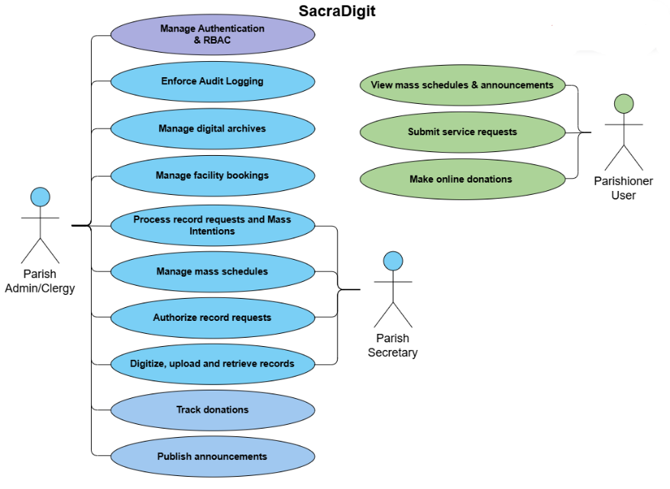
Figure 1. Use Case Diagram of the SacraDigit Parish Management System

The Context Diagram (Figure 2) positions the SacraDigit system as the central processing hub for three external actor types. The Parish Admin/Clergy, as the highest-authority administrative role, interacts with the Admin portal to oversee digital archives, approve scheduling changes, and monitor pending record requests. The Parish Secretary, as the day-to-day operational role, uses the Admin portal to process sacramental record requests, manage scheduling, record mass intentions, and publish announcements. The Public User, representing parishioners, accesses the User portal without authentication to view mass schedules, submit service requests, make donations, and access support resources.
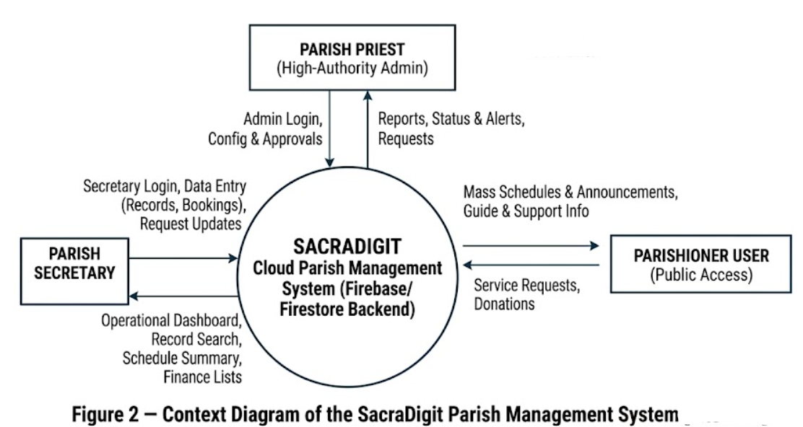
Figure 2. Context Diagram of the SacraDigit Parish Management System
The Level 1 DFD (Figure 3) decomposes the unified SacraDigit process into five major internal functional subsystems: Authentication and RBAC Management, Digital Archives Management, Scheduling Management, Finance and Intentions Tracking, and Communications Management. These subsystems correspond directly to the module structure of the Admin portal as documented in Chapter 2. Each subsystem interacts with Firebase/Firestore as the persistent data store, with read and write access governed at the security-rules layer.
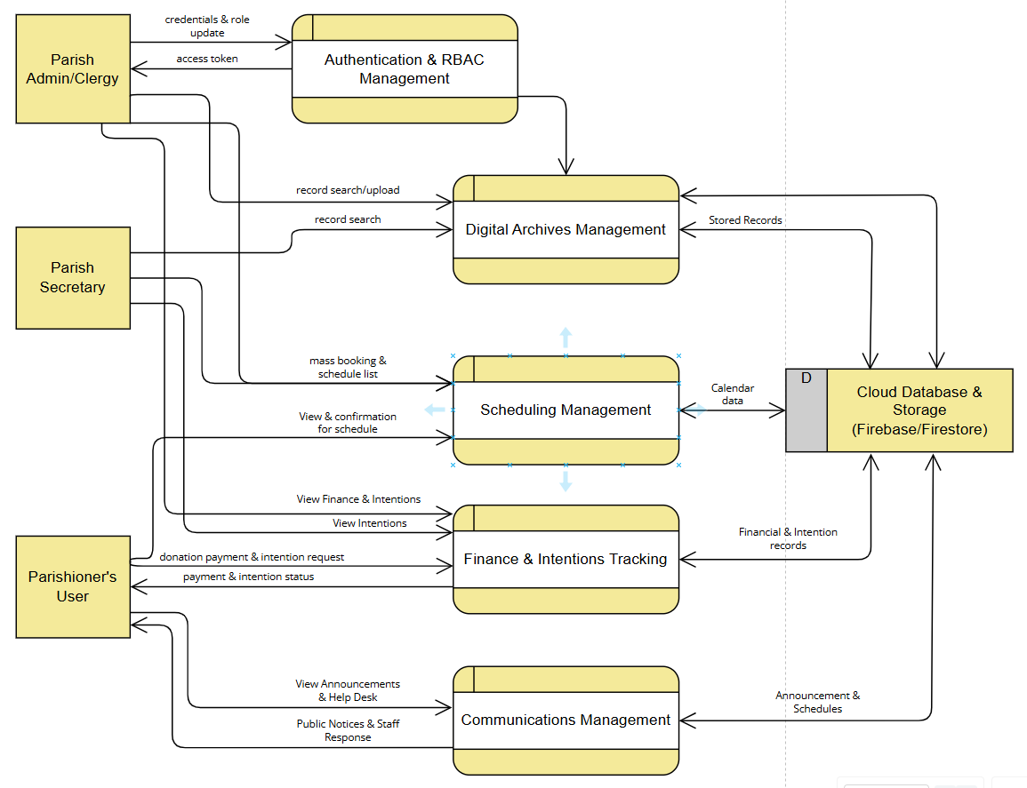
Figure 3. Level 1 Data Flow Diagram of the SacraDigit Parish Management System
Figure 4 presents the role-based module navigation structure of the SacraDigit Admin portal. The Parish Admin/Clergy role has unrestricted access to all administrative modules, including Digital Archives, Scheduling Management, Finance and Intentions, and Communications. The Parish Secretary role is granted access to Digital Archives for record retrieval and certificate request processing, Scheduling Management for mass and event coordination, Finance for mass intentions recording, and Communications for announcements. The Public User is limited to the User portal and cannot access any Admin-layer module.
The SacraDigit system is organized into six core functional modules. The Digital Archives module provides the core record digitization capability, allowing authorized admin users to upload, classify, retrieve, and process certificates for baptism, marriage, and death. The Scheduling Management module covers sacramental masses, blessing coordination, and facility bookings, with conflict detection and automated notification. The Finance and Intentions module records mass intentions and tracks parish donations. The Communications module enables the creation of announcements and special mass schedule updates. The User portal modules — Mass Times, About, Offers, Donations, Mass Intentions, and Support — are publicly accessible with no authentication requirement.

Figure 4. SacraDigit Admin Portal — Module Navigation Structure

Figure 5 presents the Entity Relationship Diagram of the SacraDigit data model as implemented in Firebase/Firestore. The primary collections include: users (with role, email, and authentication metadata), sacramentalRecords (with type, requestedBy, status, uploadedFiles, and metadata fields), schedules (with eventType, date, time, officiant, location, and status), facilityBookings (with facility, date, requestedBy, purpose, and approvalStatus), massIntentions (with names, dates, and offering amounts), donations (with donor, amount, purpose, and date), and announcements (with title, body, publishedAt, and authorId). Foreign key relationships between these collections are maintained through document ID references, consistent with Firestore's document-reference data model.
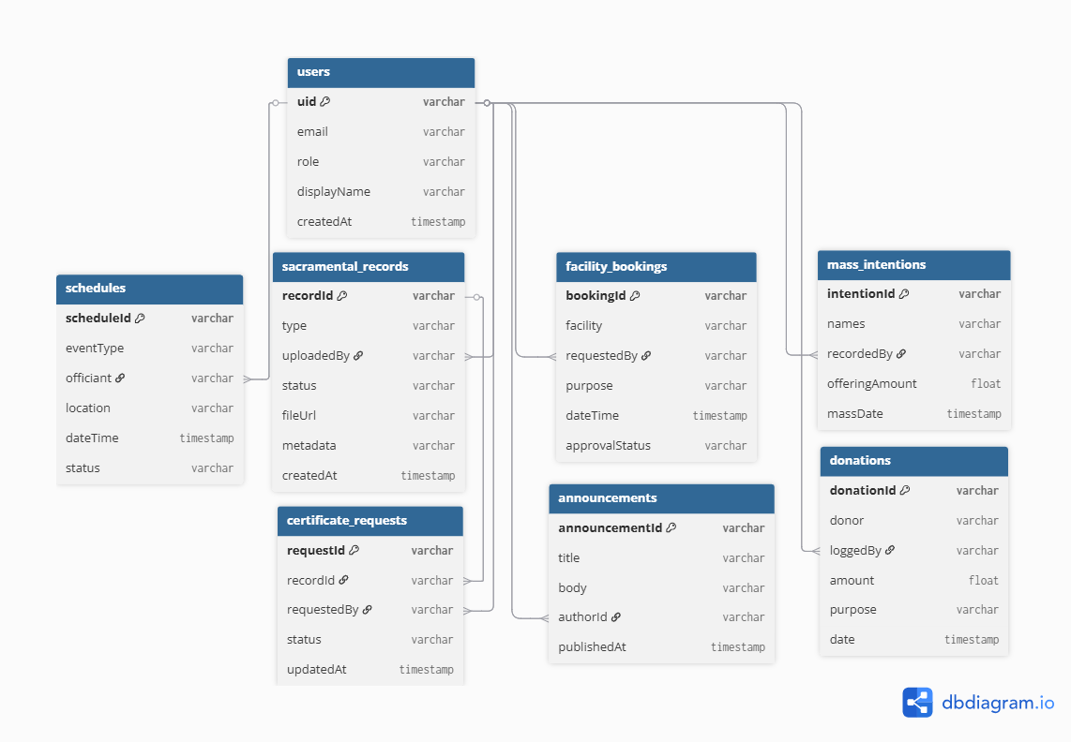
Figure 5. Entity Relationship Diagram (ERD) of the SacraDigit Firebase/Firestore Schema
Project Development
Operation and Testing Procedure
Project Design (title case, bold, left)
- What does the system look like structurally? (Web-based, mobile-based)
- Explain the overall structure of the system that can be described using system architecture
- Major functions of the system, how to design and show?
- Context DFD, top level DFD, use case diagram
- Visual Table of Contents (VITOC)
- Platform technologies

Project Development (title case, bold, left)
- How will the system be built step by step?
- If software, then it is Agile Software Development Life Cycle
- If hardware, then it is Block Diagram

Operation and Testing Procedure (title case, bold, left)
- Explain how the system is used and how the system is tested based on the criteria of ISO 25010 and at least two criteria and scenario
- Describe operation procedure or how the user interacts with the system. Step by step
- Describe testing procedure or how the researchers validate the system and ensure that the system works based on its purpose

Evaluation Procedure (title case, bold, left)
- Evaluate the acceptability, how it will be assessed
- People like clients, IT experts
- 50 respondents randomly picked
- Statistical model
- Averaging, not frequency
- Evaluation instrument adapted on ISO 25010
- 4 point Likert Scale (highly acceptable, very acceptable, acceptable, not acceptable)

